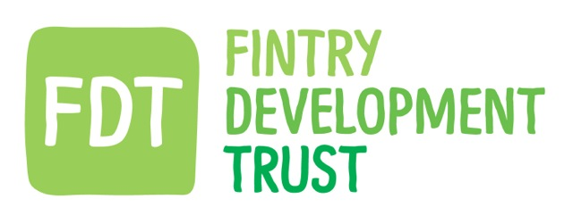

Board meeting. 23/04/15. Fintry Office. 7.30 pm.

PRESENT: David Howell, Hugh Edmond, Iain Frazer, Gordon Murray, Gordon Cowtan, Holly O’Donnell, Kayt Howell (Co-ordinator)

APOLOGIES: Matthew Black (Energy adviser), Jamie Pearson.

GUESTS: Graham Hogg (Lateral North), Dr Anne Winther (Developing sustainable communities, Research and Consultancy)

ACTION

MASTERPLAN
Graham and Anne joined the Board to present the penultimate version of the ‘Fintry Possible” report.

The Board agreed it successfully captured a snap shot in time of the requirements and ambitions of the Fintry residents, Certain aspects have already changed, such as the closure of the car club, however the investigation into the sustainable transport options remain relevant and were highlighted as one of the main concerns in the research phase.

The report forms two parts – part 1 -what was discovered through research and interviews, and part 2 – the vision of development of solutions.

The report is intended to create further actions, with each major topic area ideally having it’s own ‘champion’ to carry forward. The board discussed the report further and discussed the management of any proposed changes.

Housing had floated to the surface as one of the main concerns within the village. Anne and Graham discussed the meeting they had attended with Rural Housing and Stirling Planning Department.

The Board were interested in the development and feasibility of the sustainable elements of any proposal but stated that the Community Council were the group with whom further feasibility studies should be discussed given their on going involvement with the current proposals. JP to be contacted. KH

The Board congratulated Anne and Graham on their work and agreed to publicize the presentation of the report at the next FCC meeting on 13th May 2015.

FUNDING PROPOSAL – Prof Geoff Williams

Professor Williams has been in touch to ascertain what the Board would like to pursue as a starter project.

The Board discussed the proposals, which had been presented in previous discussions, - Geo thermal, Electricity storage, Hydro, Smart metering. The Board agreed that Geoff should be asked to provide us with some guidance as to which subject would fit best for this stage of funding. KH

FEET CLOSURE

KH reported on the winding up admin tasks for the car club. Members have been contacted regarding deposit and membership refunds.

The board discussed the disappointment in the decline in active users coupled with withdrawal of Government Funding for Rural Car Clubs. The end of year figures had made clear the unsustainability of the car club despite continued and creative efforts to promote the club to a wider market.
It was agreed that participation in running the Car club had proved to be a valuable exercise, within the parameters of trying to correctly address the sustainable transport needs of the village. FDT will continue to look at alternative solutions and possibilities within Fintry.

It was clearly voiced, and unanimously agreed by the Board that the difficult and upsetting misinterpretation of our closure decision, by Carplus, was most unfortunate and had made the closure unnecessarily difficult.

BOWLING CLUB CLOSURE

KH & DH had attended meetings with the surrounding neighbours of the club and the FCC meeting the previous evening. They reported on the agreed need for ideas and potential solution for the land where the club currently sits.
The club will remain insured and have services kept running until October by which time there hopes to be some suitable solution to maintaining the club facilities for community use. FCC welcomes all ideas.

DATE of NEXT MEETING – 27th May 2015

