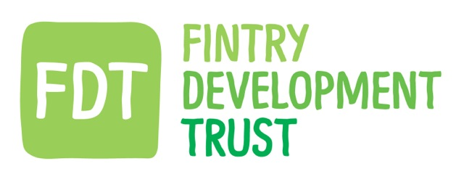
FDT minutes for 26.08.15. HQ 7.30pm

PRESENT: David Howell, Kayt Howell (Co ordinator), Holly O’Donnell, Jamie Pearson, Gordon Cowtan, Matthew Black (Senior Energy Adviser)

APOLOGIES: Gordon Murray, Hugh Edmond, Iain Frazer

Guest – Sandy Wito of Veitch Cooper.

ACTION

Smart Meters.

MB introduced Sandy.
Sandy has been working with MB, through the Cares Infrastructure and Innovation Fund to assess the feasibility of utilizing Smart Meters as a method of off-setting the energy produced by the Strathendrick AD plant against the energy used in the Fintry Village.

The smart meter project would aim to create a virtual connection, to match consumption with production.
Sandy gave a presentation of the feasibility study findings to the Board and discussed the potential savings and benefits to the community in terms of householder fuel bill savings, energy efficiency, 100% green energy and the carbon reduction of the community.

An LES grant of £25K allows Veitch Cooper and FDT to explore the potential of implementation of a Smart Meter system in Fintry and assess the homeowner and business needs and level of interest for the proposal.

The Board discussed various issues regarding Ofgem, FITs, grid limitations, software etc.
Sandy’s presentation was very interesting and thought provoking and focused on the benefits to the village.

Sandy and MB will be working on the details of the project and will keep the board up to date with their progress and findings. They are working toward the second stage application for funding, for the implementation costs of the project, in February 2016.

It was agreed that the community consultation aspect of the project should be the main focus at the AGM. MB

MEMBERSHIP CORRESPONDENCE

No direct correspondence has been received.

FURTHER EDUCATION GRANT

Four applications were received for the FDT Further Education Grant.
The board, against the grant criteria, considered all applications.

Two applications were successful, one was referred for further information and one was refused.

The Board discussed the applications and the awards and agreed that each future application will be guided towards a successful application, however if unsuccessful, should be referred to the FCC to access the Goodwill fund or a separate bursary which the Council hope to create.

The grant remains open for further applications and will be promoted again in the next newsletter and at the AGM. KH, BOARD
FCC GOODWILL FUND.
A further payment to the fund for £2650.00 will be made.to Fintry Community Council. KH, GC

RESERVED BUSINESS

BALGAIR

MB reported on the final stages, and snagging issues, for the Balgair District Heating System project.
95% of users are extremely happy, however issues remain with the monitor equipment and the loss of signal.
MB explained the next stages to rectify the problem and the frustration of this one issue remaining outstanding.
DH asked about one resident’s issues with flow & return to radiators. This has been resolved.
DH asked if a retention was being held until all problems and issues have been successfully addressed. MB confirmed this.

A report on the project will be given at the AGM. MB

FINESSE –(Fully Integrated Network of Energy Supply, Storage and Efficiency)

FDT is consulting with academic and design partners from Durham and Glasgow universities in an expression of interest application to Innovate UK.
The proposal will investigate the use of state of the art technology to maximize the potential for supply and storage of energy in Fintry.

The Board agreed with supporting this stage of the application and will advise Professor Williams.

STIRLING’S LOW CARBON FUTURE

HOD reported on the successful progress of our partnership project with Transition Stirling. With the year of funding from CCF moving along at a pace, the role of the FDT board beyond this and in the future funding of the Project was discussed.
The Board agreed that the Trust will support the group with a Board director’s role, but will let the project fly solo on funding applications etc. HOD, GC

AGM

The AGM date is agreed as Saturday 31st October 2015, Menzies hall at 2pm.
The meeting will follow the usual format and will be publicized in the Focus, FDT newsletter, posters etc.

No one has come forward as yet to stand as a director. Two positions will be available – Iain Frazer will stand for re-election and the position vacated by Pete Skabara will be available.

A summary leaflet will be made available on the day for members to take away and for FDT to put online for those who are unable to attend.

Due to the length of the meeting , other items were put on hold for next meeting

Date proposed as 30th September. Usual place and time.

