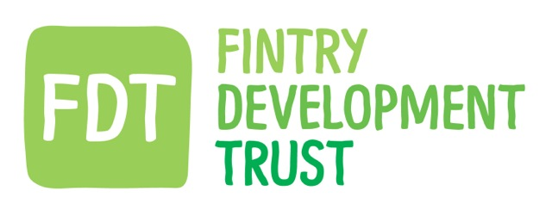

DATE : 29.09.16 LOCATION: HQ (snug) TIME:7.30pm

DIRECTORS & STAFF | Present | Apologies
David Howell (Chair) | Y
Gordon Cowtan ( Treasurer ) | Y
Holly O'Donnell | Y
Hugh Edmonds |  | Y
Iain Frazer | Y
Stuart Higgins |  | Y
Gordon Murray |  | Y
Jamie Pearson (FCC Chair) | Y
Matthew Black ( Sen. Energy Advisor) |  | Y
Kayt Howell (Manager) | Y
Other Guest.

Previous minutes approved.

Agenda Item No. | Summary Discussion | Decision | Action.
1 SMART Fintry | GC reported on the projects progress. The GA almost there and once signed lots of movement expected on tariff sign ups etc.  Event planned for 21st /22nd Oct. at FSC.  Directors discussed various aspects of the project sign up conditions. | For GC & MB to keep the Board aware of the project progress | GC MB
 | GC gave summary of the funding progress for the GSHP project at Dunmore Gdns. Directors discussed the disruption issues and the general cash flow needs of the project.
2. Earlsburn Extension Fund | JP reported in the current position of sharing the fund between the 6 communities and Falcks decision. | The board agreed how this will impact on the existing Goodwill fund. And the additional benefits to the community. | JP (FCC ) and FDT Board.
 | Directors discussed the management of the fund and FDT’s role in this. | FDT terms of governance of the fund to be fully agreed.
3. Fintry Transport | Leading on from the above JP and the Board discussed the various ways we might consider improving the transport situation for the village. | All agreed to consider the options and look in more detail at some of the ideas including -  Drivers Bank  Free seat share  DRT extension. | FCC & FDT
4. AGM | Directors discussed the reasons for moving the AGM date this year. | Decision is to hold the AGM in FEB.  HOD will check when the School holiday dates are. | FDT HOD KH
5. Bank accounts | GC explained the process had begun of switching the FDT account to BoS. | Directors will all need to participate in the form filling processes. Other accounts will follow. | Directors GC & KH
6. Accountants | The board discussed the issues and need for change. GC explained current status. | GC will keep the Board posted of progress. | GC KH
7. Harvest dinner | The Board has been invited to the dinner at the Sports Club . | KH DH GC may attend. | ALL
8. Board Meetings |  | Will be on the last Wednesday of each month unless a change is required | Board KH MB
AOB | Invitation to take part in Xmas tree festival | Agreed. Send reply. | KH.
 | Tree at Fintry Cross | FDT will provide LED lights – Solar if poss.  JP will let those involved know. | JP KH MB

Information to be separately minuted:

Objections to be recorded:

Date of Next Meeting

